10PEARLS
10Shine Internship Program

Assignment No. 2

Test Plan and Test Case Writing
Project: Online Book Store
Domain: Quality Assurance (Manual + Automation)

Submitted by: Muhammad Faizan Anwar
QA Intern – 10Shine Cohort

1. Introduction & Objective
Following the Requirement Analysis and User Story creation in Assignment 1, this phase focuses on translating BDD/Gherkin acceptance criteria into formal, executable Test Cases. Utilizing Testworthy as the core Test Management Tool, this report documents the end-to-end process of project configuration, test suite organization, test planning, and simulated execution.

2. Project & Milestone Configuration
To simulate a real-world Agile environment, the project was established in Testworthy and aligned with our primary Sprint Goal.

- Project Name: 10Shine-OnlineBookStore
- Milestone Created: Sprint 1 - MVP Authentication & Checkout
- Objective: To track test execution specifically against the MVP features outlined in the initial Sprint Planning phase.

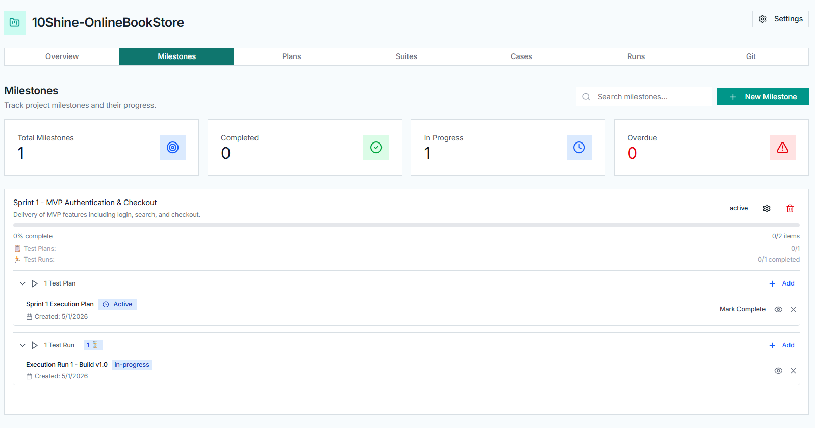

3. Test Suites & Section Structuring
To ensure high traceability and maintain a clean test repository, Test Suites were mapped to the project Epics, and nested Sections were created for individual User Stories.
The structure was organized as follows:

Suite: Epic 1: Authentication & Security
  - Section: User Story - Secure Login & OTP

Suite: Epic 2: Catalog & Search
  - Section: User Story - Book Search & Filtering

Suite: Epic 3: Shopping Cart & Checkout
  - Section: User Story - Secure Payment Processing

Suite: Epic 4: Account Management
  - Section: User Story - Order History & Addresses

Suite: Epic 5: Admin Dashboard
  - Section: User Story - Inventory & Catalog Controls

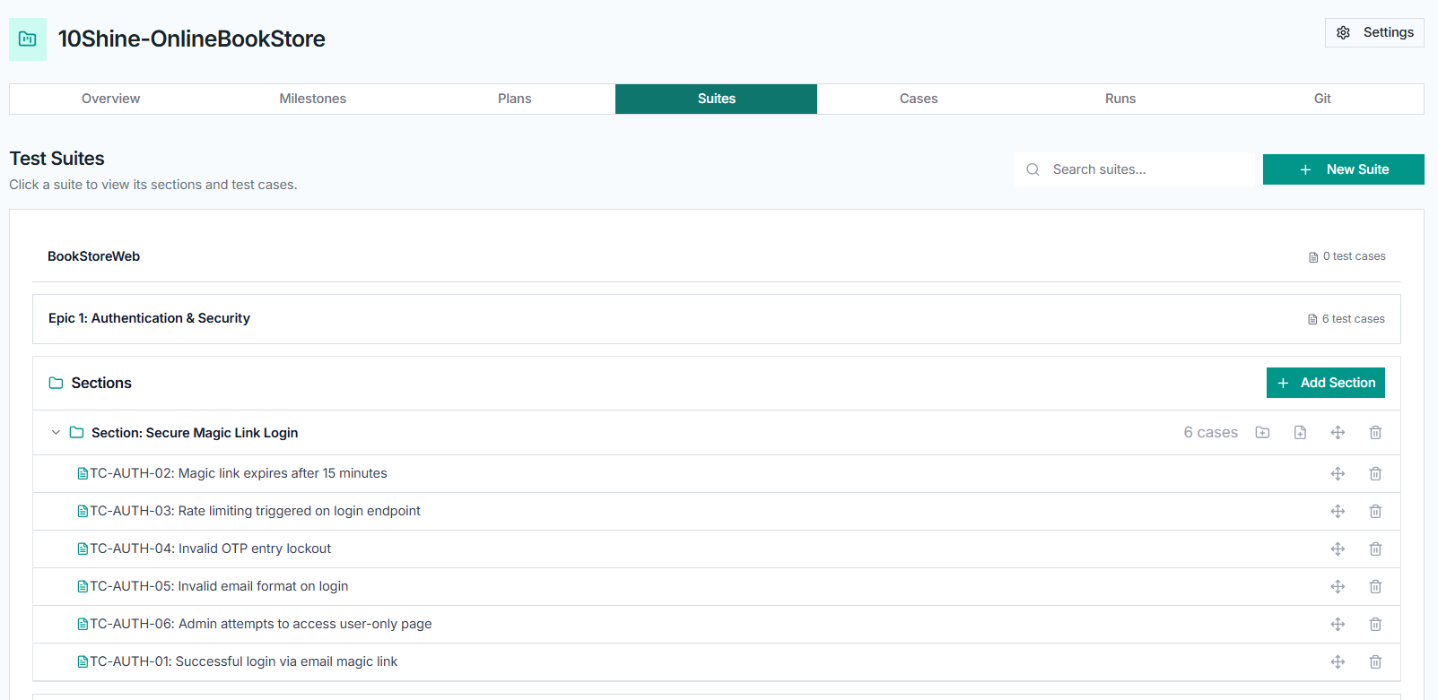
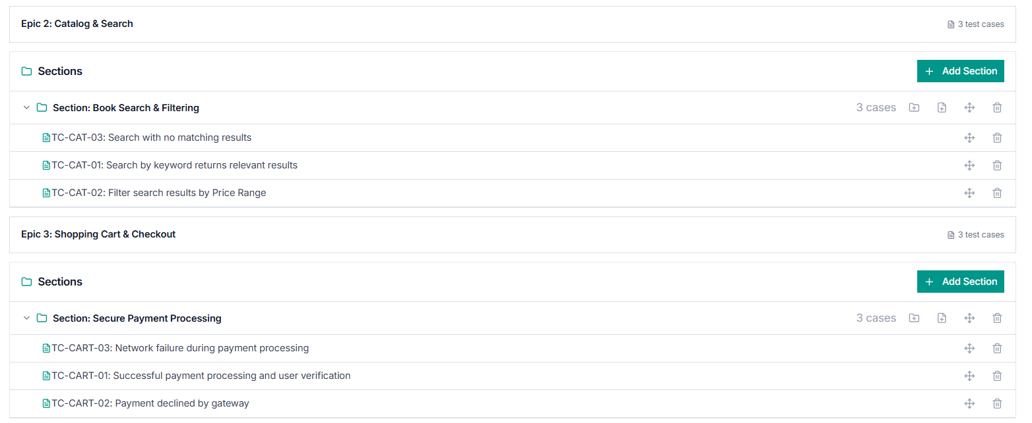

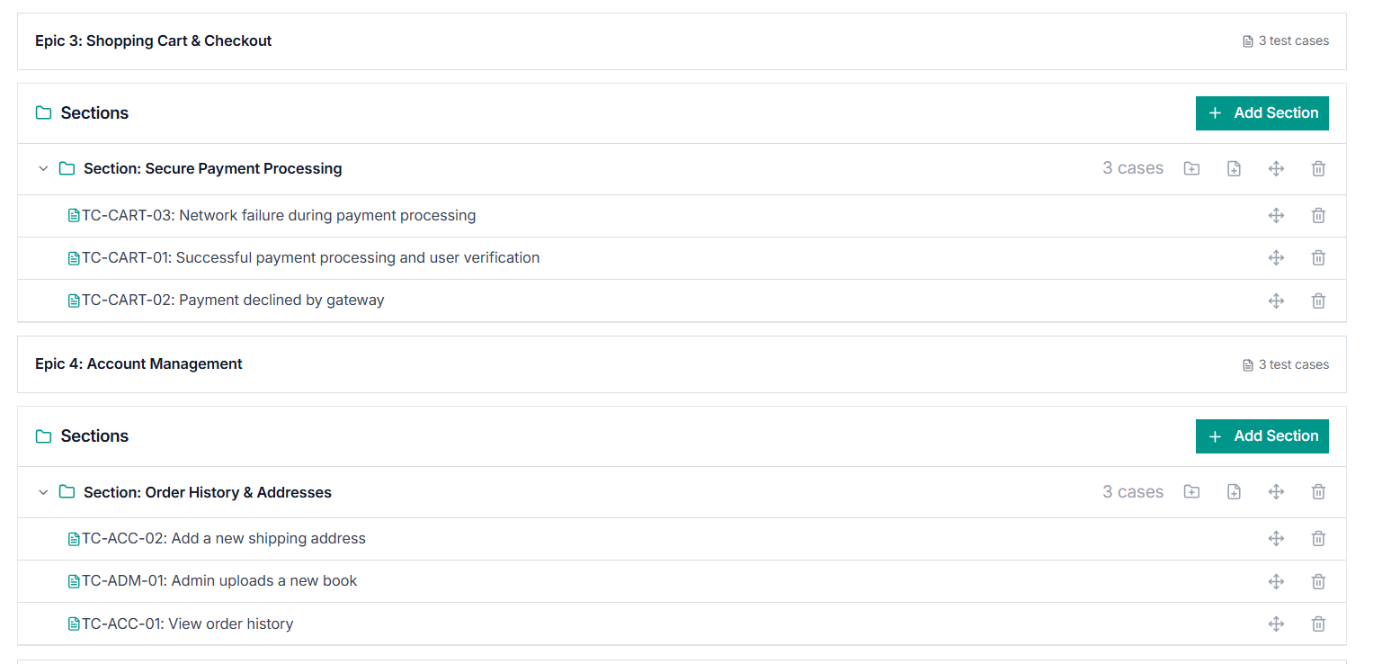
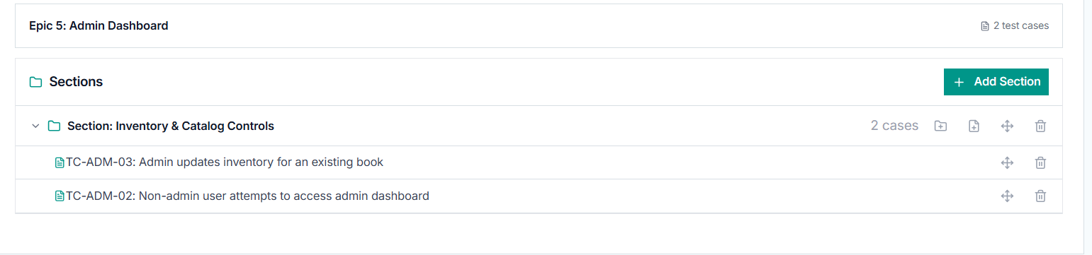

4. Test Case Design & Classification
Detailed test cases were written for each scenario. To ensure robust test coverage, cases were deliberately classified by Type (Functional, Security, Negative) and Priority (Critical, High, Medium, Low).

Coverage Highlights:
- Smoke/Happy Path: e.g., TC-AUTH-01: Successful login via email magic link
- Negative Testing: e.g., TC-AUTH-05: Invalid email format on login
- Security Testing: e.g., TC-AUTH-03: Rate limiting triggered on login endpoint
- Edge Cases: e.g., TC-CART-03: Network failure during payment processing

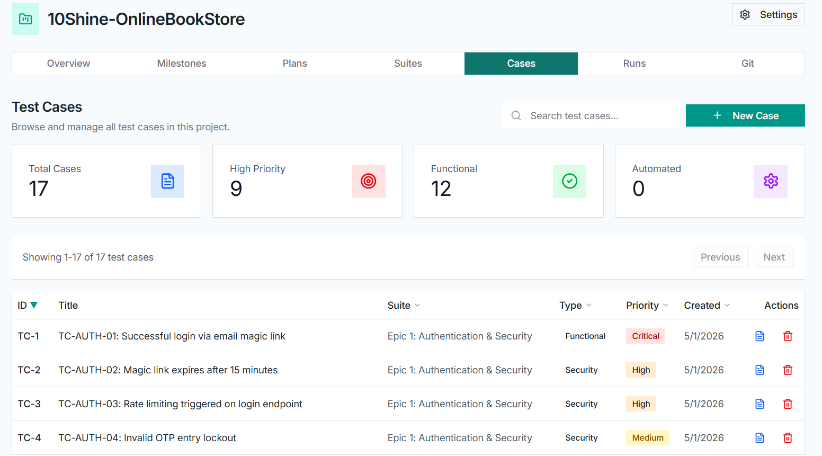

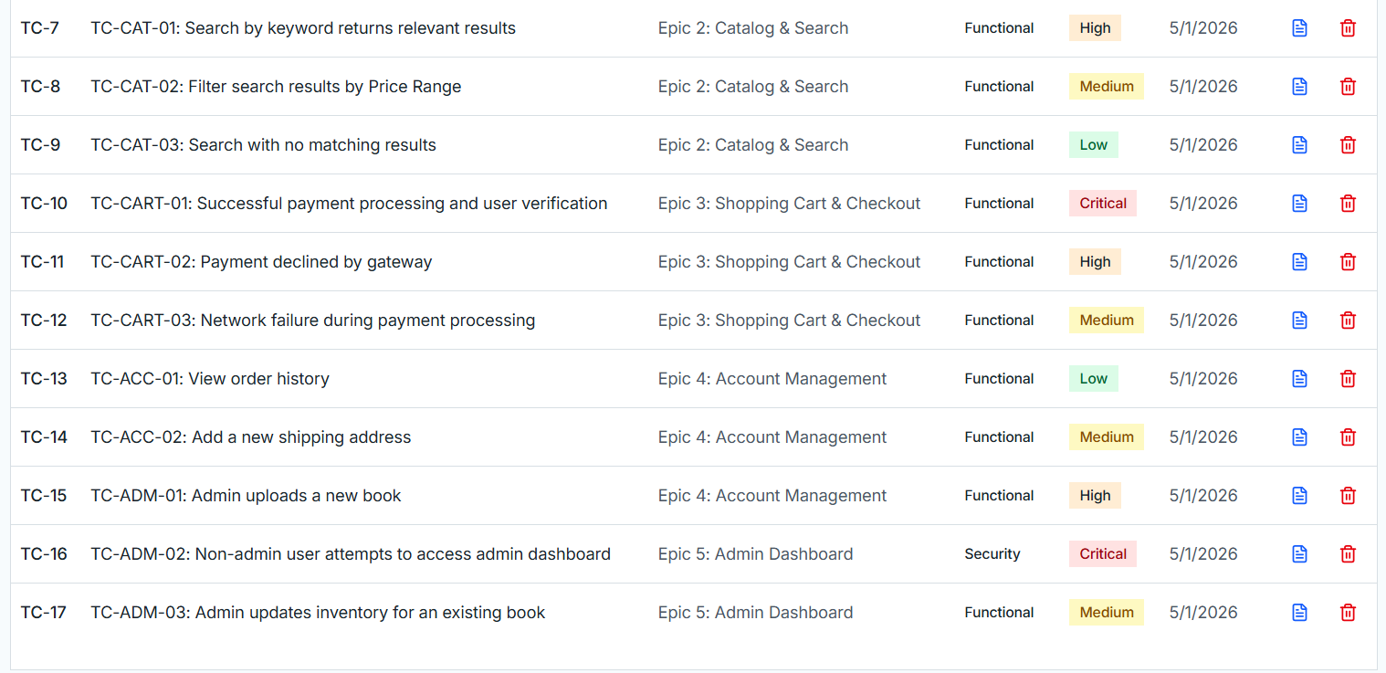

5. Test Planning & Execution (Test Run)
A formal Test Plan was constructed to bind the test cases to the active Sprint.

- Test Plan Name: Sprint 1 Execution Plan
- Linked Milestone: Sprint 1 - MVP Authentication & Checkout
- Execution Run: Execution Run 1 - Build v1.0

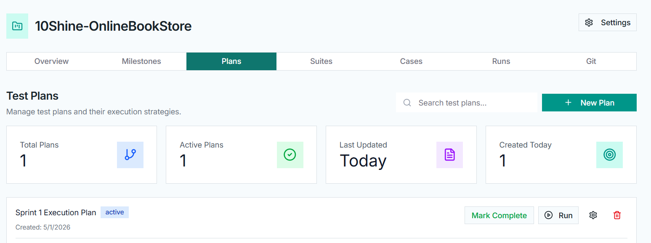

Simulated Execution Results:
During the execution phase, test statuses were manually marked. To reflect a realistic software testing cycle, not all tests were passed.

- Passed: Verified core functionalities (Search, valid Checkout, Admin access).
- Failed: Simulated a bug discovery on TC-AUTH-04 with the execution note: "Bug: System does not invalidate OTP after 3 failed attempts as expected. It allows infinite retries."
- Blocked: Simulated a blocked test due to a third-party gateway timeout.
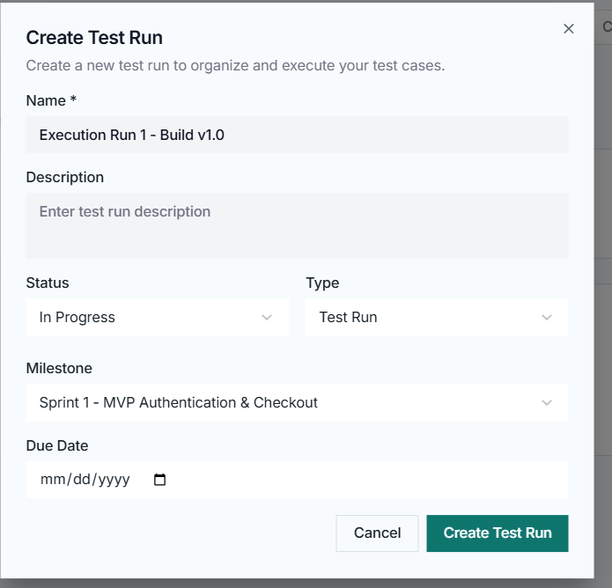
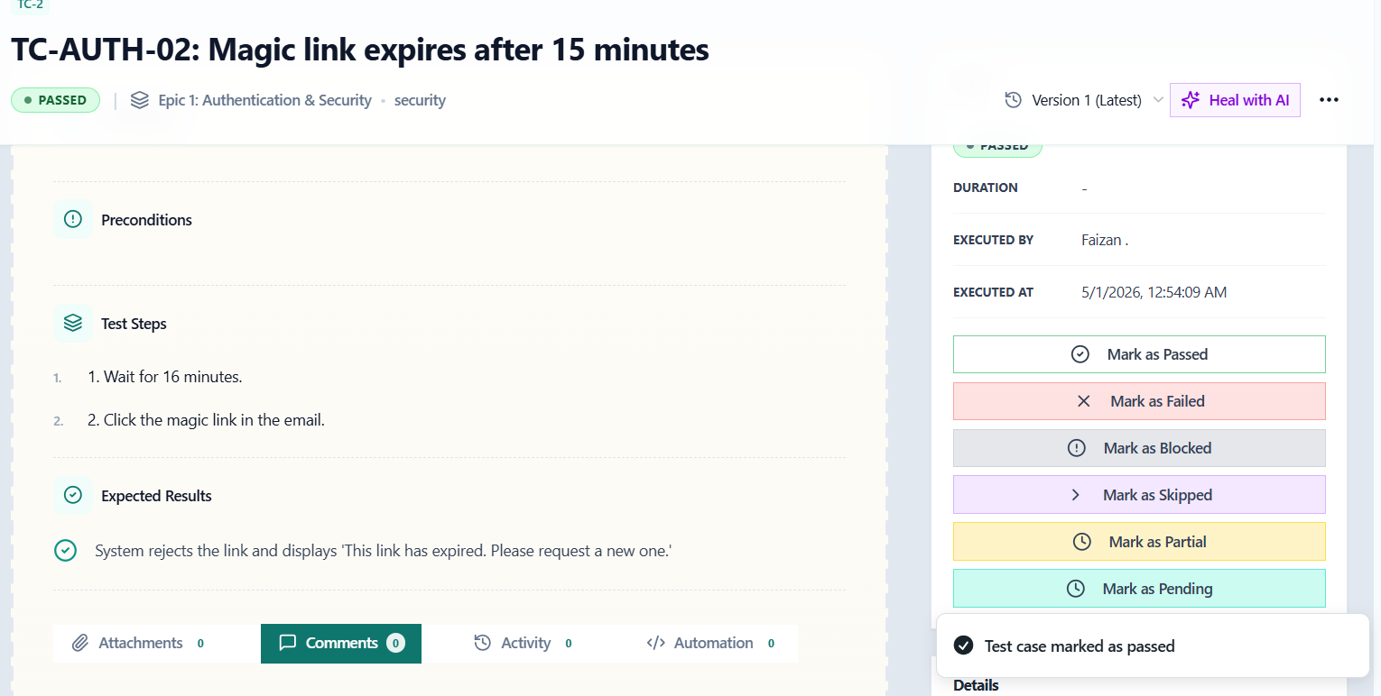
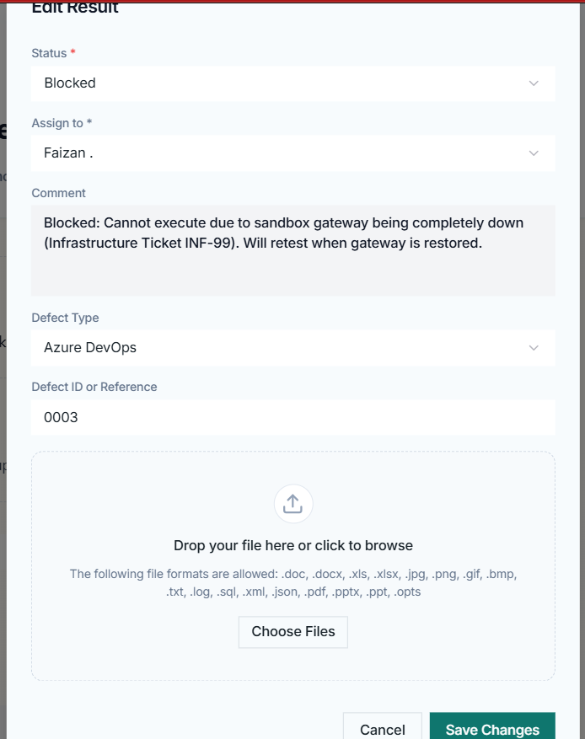

Results & Statistics

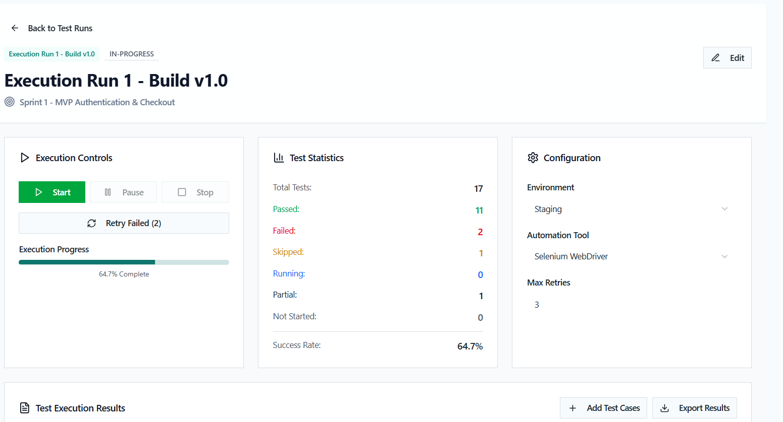

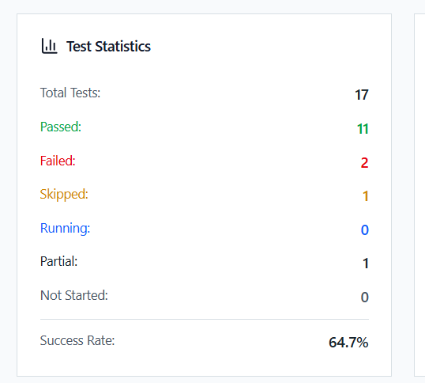

6. Final Deliverables & Artifacts
The following artifacts have been generated from Testworthy to provide complete evidence of test management and execution:

Exported Test Cases (CSV): The raw test case data including Preconditions, Steps, and Expected Results has been exported.

Execution Summary Report (PDF): The formal Test Run Summary generated via Testworthy's reporting module.

